1.Create a bash script tocheck if a directory is available or not ?
Ans Bash Script to Check Whether a Directory Exists – Steps
- Open the Ubuntu/Linux terminal.
- Create a new Bash script file using the vi editor.
- Give the script a suitable name, such as checkdir.sh.
- Start the script with the Bash interpreter.
- Ask the user to enter the directory name.
- Use the -d condition to check whether the entered directory exists.
- If the directory exists, display a message saying “Directory exists.”
- If the directory does not exist, display “Directory does not exist.”
- Save the Bash script.
- Give the script execute permission.
- Run the script from the terminal.
- Enter a directory name when prompted.
- The script will display whether the directory is available or not.
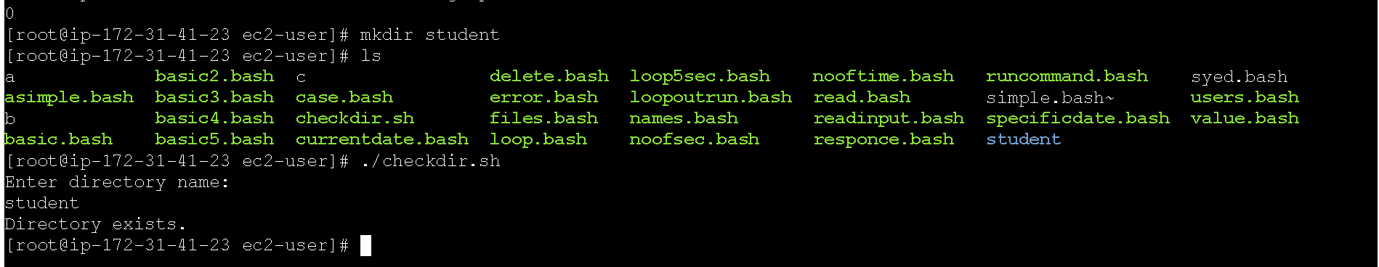

2 , Create a bash script tocreate multiple files ?
Ans Bash Script to Create Multiple Files in Linux – Steps
- Open the Ubuntu/Linux terminal.
- Create a new Bash script using the vi editor.
- Give the script a name, such as createfiles.sh.
- Write the Bash script to create multiple files.
- Specify the names of the files that need to be created.
- Use the touch command to create the files.
- Save and exit the script.
- Give the script execute permission.
- Run the Bash script.
- Use the ls command to verify that all the files have been created.
- The specified files will appear in the current directory.
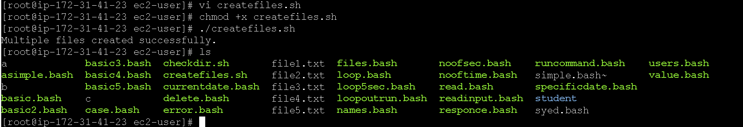

3) Create a bash script to take a backup of a directory ?
Ans Bash Script to Take Backup of a Directory – Steps
- Open the Linux terminal.
- Create a new Bash script file using the vi editor.
- Name the script backup.sh.
- Add the Bash interpreter at the beginning of the script.
- Ask the user to enter the directory name.
- Read the directory name entered by the user.
- Use the tar command to create a compressed backup of the directory.
- Save the backup with the name backup.tar.gz.
- Display a message that the backup was created successfully.
- Save and exit the Bash script.
- Give execute permission to the script.
- Run the Bash script.
- Enter the directory that you want to back up.
- Use the ls command to check whether backup.tar.gz was created.
- Result: The selected directory is successfully backed up.
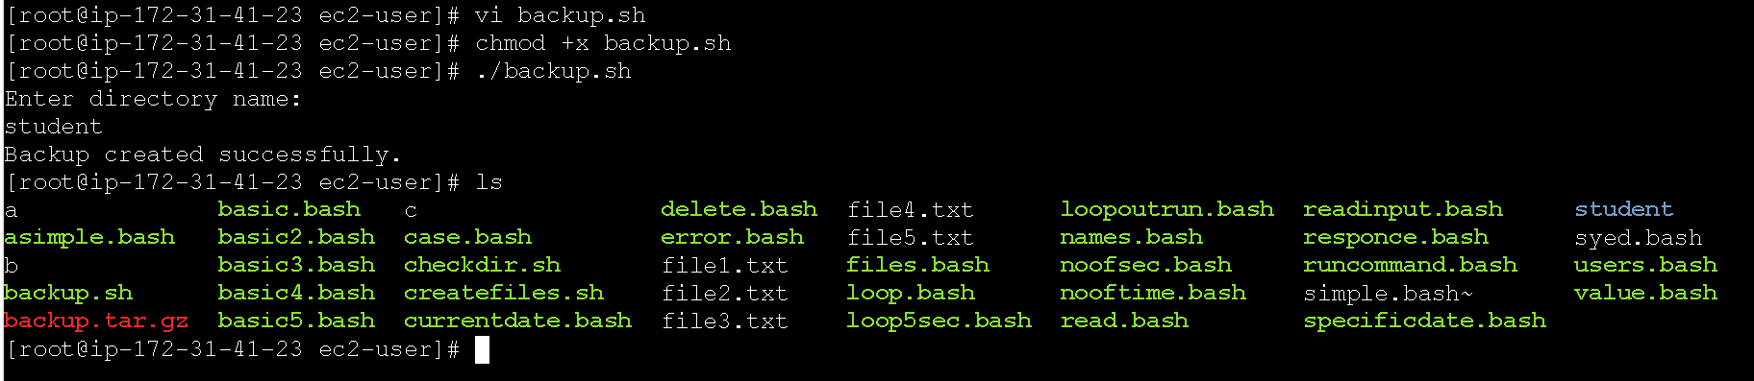

4; : Create a bash script toinstall Nginx on an EC2 server ?
Ans Practical: Bash Script to Install Nginx on an EC2 Server
- Launch an EC2 instance with Ubuntu Linux.
- Connect to the EC2 server using SSH.
- Open the terminal.
- Create a Bash script using the vi editor.
- Name the script install_nginx.sh.
- Add commands to update the package repository.
- Add the command to install Nginx.
- Add a command to start the Nginx service.
- Enable Nginx so that it starts automatically when the server reboots.
- Save and exit the Bash script.
- Give execute permission to the script.
- Run the Bash script.
- Check the Nginx service to confirm that it is running.
- Open the EC2 instance's Public IP address in a web browser.
- If the EC2 Security Group allows HTTP traffic on port 80, the Nginx welcome page will be displayed.
- Result: Nginx is successfully installed and running on the EC2 server.
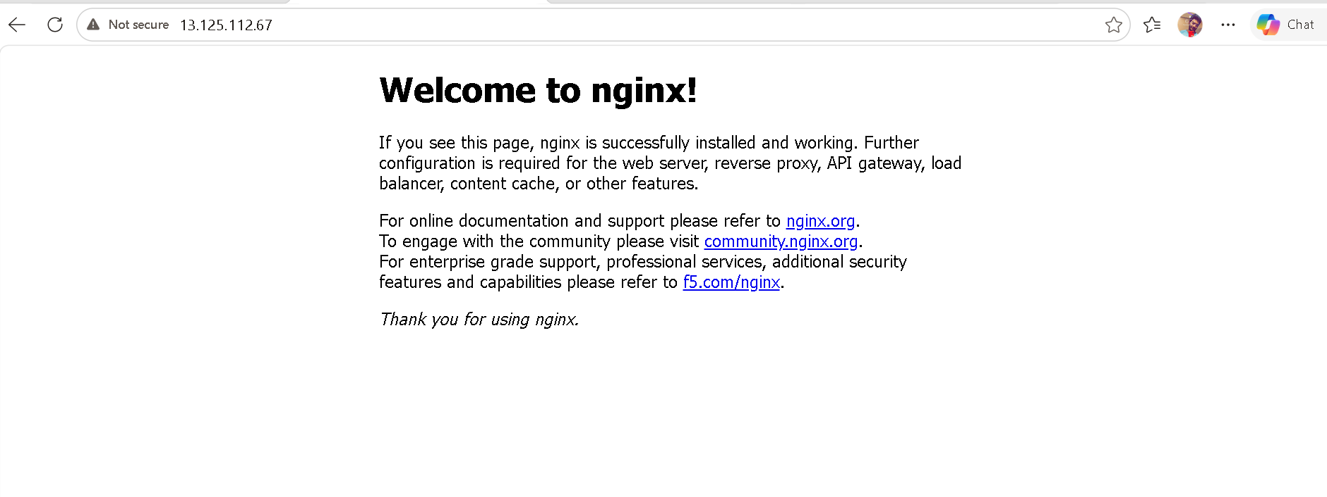
5 Create a bash script toinstall Apache Tomcat on an EC2 server ?
Ans Steps to Install Apache Tomcat on an EC2 Server
- Launch an EC2 Instance
Create and launch an EC2 instance using Amazon Linux.
- Connect to the EC2 Instance
Connect to the instance using EC2 Instance Connect or SSH.
- Update the System
Update the installed packages on the Amazon Linux server.
- Install Java
Install Java because Apache Tomcat requires Java to run.
- Create a Tomcat Directory
Create a directory under /opt to store the Tomcat installation files.
- Download Apache Tomcat
Download the Apache Tomcat archive from the official Apache Tomcat website.
- Extract the Tomcat Files
Extract the downloaded archive into the Tomcat directory.
- Set Permissions
Give the required execution permissions to the Tomcat startup and shutdown scripts.
- Start Apache Tomcat
Start the Tomcat server using its startup script.
- Verify Tomcat
Check whether Tomcat is running and listening on port 8080.
- Configure the EC2 Security Group
Add an inbound rule to allow TCP port 8080 so that Tomcat can be accessed from the internet.
- Test in a Web Browser
Open the EC2 public IP address followed by port 8080 in a browser.
- Verify the Result
If the Apache Tomcat welcome page appears, the installation and configuration are successful.
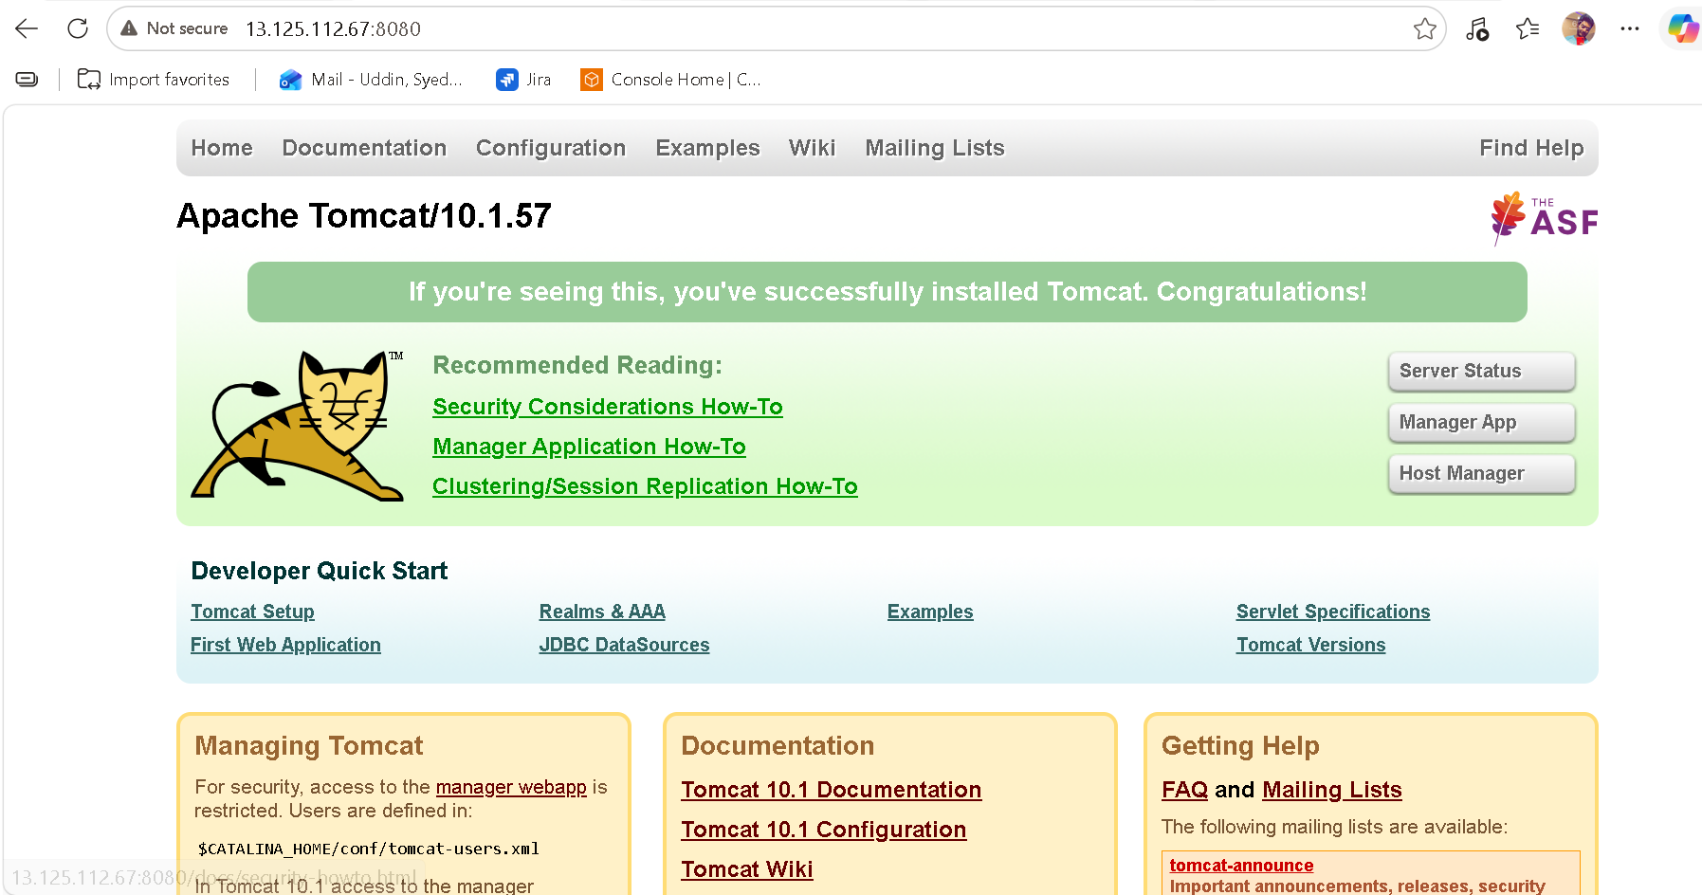

6. Create a bash script tocheck if the Nginx service is running, if
not running then script should start the service. ?
- ans Connect to the Amazon Linux EC2 instance.
- Open the terminal and switch to the root user.
- Create a Bash script named check_nginx.sh.
- Write the Bash script to check whether the Nginx service is running.
- Use a condition to determine the status of the Nginx service.
- Display a message if Nginx is already running.
- Start the Nginx service if it is not running.
- Check the Nginx service again after starting it.
- Display a success message if Nginx starts successfully.
- Give execute permission to the Bash script.
- Run the Bash script and verify its output.
- Stop Nginx temporarily to test whether the script can automatically start it.
- Run the script again and verify that it starts Nginx.
- Check the Nginx service status to confirm that it is active and running.
- Result: The Bash script successfully monitors the Nginx service and automatically starts it whenever it is not running.
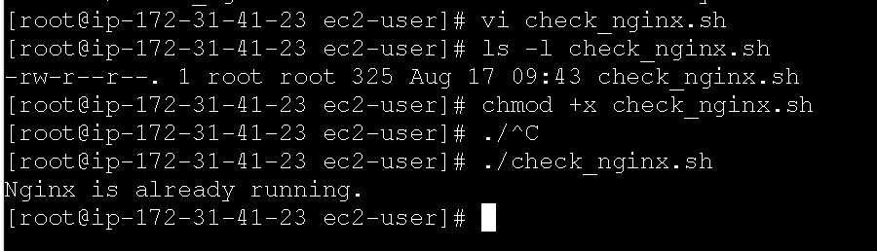

07/ Create a bash script for a calculator ?
Ans Practical: Bash Script for a Calculator
Here is a simple calculator that performs addition, subtraction, multiplication, and division.

Steps to perform
- Create a file named calculator.sh.
- Open the file and enter the calculator script.
- Save the file.
- Give execute permission to the script.
- Run the script.
- Select an operation from the menu.
- Enter the first number.
- Enter the second number.
- The script calculates and displays the result.
- Verify the result for addition, subtraction, multiplication, and division.
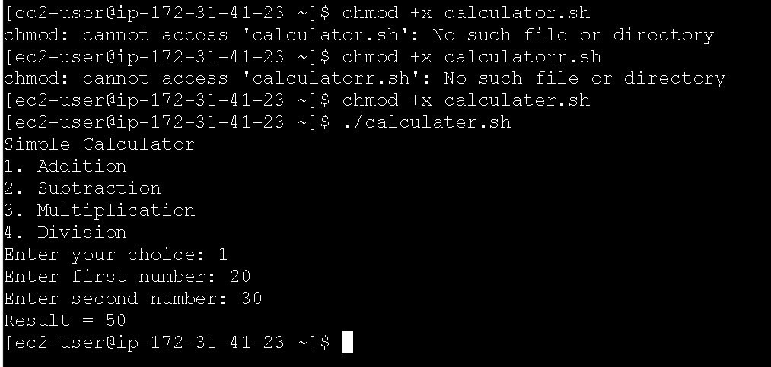
8 . Create a bash script tocheck if a directory exists, if not then
create a directory. ?
- Connect to the Amazon Linux EC2 server.
- Open the terminal.
- Create a Bash script named check_directory.sh.
- Write the script to ask the user for a directory name.
- Check whether the specified directory already exists.
- If the directory exists, display a message saying that the directory already exists.
- If the directory does not exist, create the directory.
- Display a message confirming that the directory was created successfully.
- Save the Bash script.
- Give execute permission to the script.
- Run the Bash script.
- Enter a directory name when prompted.
- Verify the result by checking the contents of the current directory.
- Run the script again with the same directory name to confirm that it detects the existing directory.
- Result: The script successfully checks for a directory and creates it automatically if it does not exist.
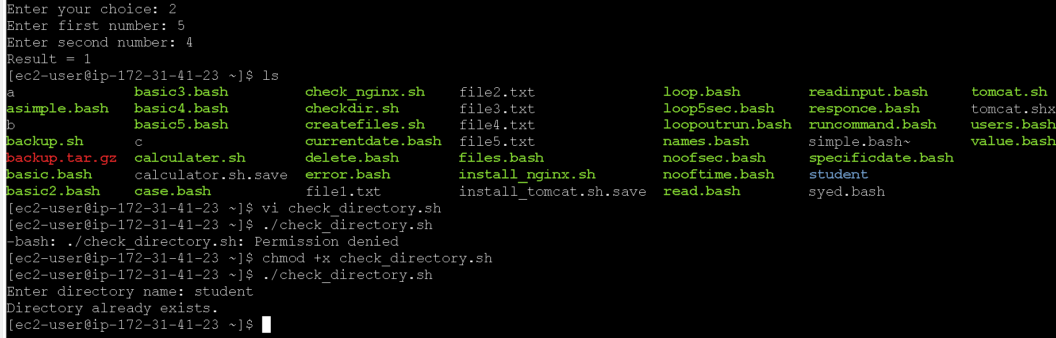

9- Create a bash script todelete the last 3 lines of a file. ?
- Ans Connect to the Amazon Linux EC2 server.
- Open the terminal.
- Create a sample file using the vi editor.
- Add several lines of text to the file.
- Save and exit the vi editor.
- Create a Bash script named delete_last3.sh using the vi editor.
- Write the script to accept the file name from the user.
- Check whether the specified file exists.
- If the file exists, delete the last three lines from the file.
- If the file does not exist, display an appropriate error message.
- Save and exit the vi editor.
- Give execute permission to the Bash script.
- Run the Bash script.
- Enter the name of the file whose last three lines should be deleted.
- Display the contents of the file after running the script.
- Verify that the last three lines have been successfully removed.
- Result: The Bash script successfully deletes the last three lines from the specified file.
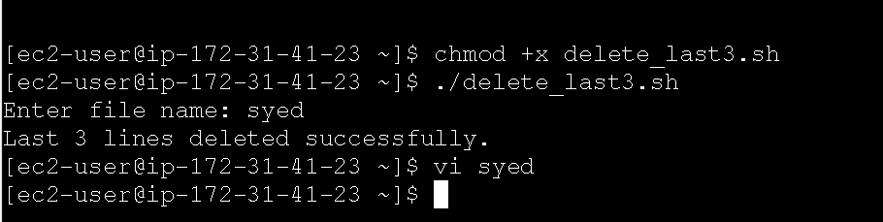

10_ Practical: Bash Script to Monitor CPU Usage and Send Email if Above 80% create bash ?
Ans Practical: Bash Script to Monitor CPU Usage and Send Email if Above 80%
Since you are using Amazon Linux EC2, you can use mail/mailx with an SMTP service to send the notification.
Steps
- Connect to your Amazon Linux EC2 instance.
- Install the required packages for CPU checking and email notification.
- Create a Bash script named cpu_monitor.sh.
- Use the top command to obtain the current CPU usage.
- Calculate the CPU usage percentage.
- Set the CPU threshold to 80%.
- Compare the current CPU usage with the threshold.
- If CPU usage is greater than 80%, generate an alert message.
- Send the alert message to the configured email address.
- If CPU usage is below 80%, display that CPU usage is normal.
- Give execute permission to the script.
- Run the script and verify the CPU usage.
- Test the script by creating high CPU load if required.
- Verify that an email notification is received when CPU usage exceeds 80%.
- Result: The script monitors CPU usage and sends an email notification when CPU usage goes above 80%.
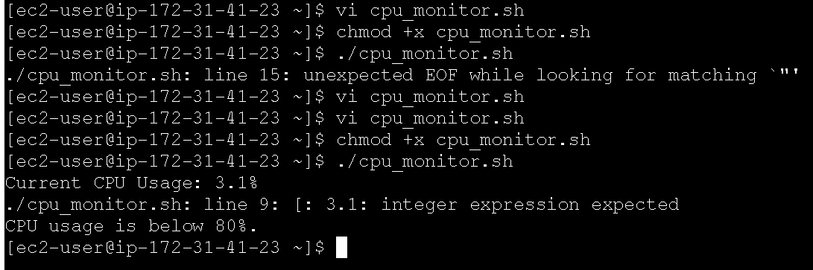
11; Bash script to monitor disk space and if it is more than 80%
then send email notification ?
- ans Connect to the Amazon Linux EC2 server.
- Open the terminal.
- Create a Bash script named disk_monitor.sh using the vi editor.
- Write the script to check the disk space of the root (/) filesystem.
- Calculate the current disk usage percentage.
- Set the disk usage threshold to 80%.
- Compare the current disk usage with the 80% threshold.
- If the disk usage is below 80%, display a message that the disk usage is normal.
- If the disk usage is above 80%, generate a disk space alert.
- Configure the email address where the notification should be sent.
- Send an email notification when disk usage exceeds 80%.
- Save and exit the vi editor.
- Give execute permission to the Bash script.
- Run the Bash script.
- Check the current disk usage and verify the result.
- Test the script by increasing the disk usage above 80% if required.
- Verify that the email notification is generated when the disk usage exceeds 80%.
- Result: The Bash script successfully monitors disk space and sends an email notification when disk usage goes above 80%.
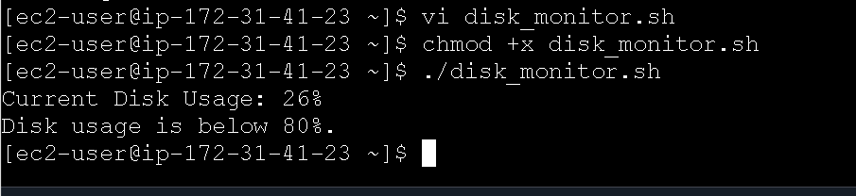

12> Bash script to monitor memory and if it is more than 80%
then send email notification ?
ans Steps to Monitor Memory Usage and Send Email
- Create a Bash script using the vi editor.
- Write the memory monitoring commands inside the script.
- Check the current memory usage of the Linux server.
- Calculate memory usage in percentage.
- Set the condition to check whether memory usage is greater than 80%.
- If memory usage is more than 80%, the script should send an email notification.
- If memory usage is 80% or less, the script should continue without sending an email.
- Save the Bash script and exit the vi editor.
- Give execute permission to the script.
- Run the script and verify that it works correctly.
- Finally, schedule the script using cron so that memory usage is monitored automatically at regular intervals.
